Chapter 9: Earth, Sun and Moon

9.1 The Earth, Sun and Moon interact with each other

Literacy support worksheet answers (pages 156–157)

Earth, Sun and Moon interactions

1 Without the Sun we could not survive.

a What is the Sun?

The Sun is a star.

b Describe what is the Sun is like?

The Sun is an incredibly hot and very large ball of gas (or, more correctly, plasma).

c What does the Sun provide for the Earth?

The Sun provides the Earth with heat and light.

2 To explain why the Earth experiences daytime and night-time, label the diagram below with the words *axis*, *equator*, *North pole* and *South pole.* In addition, include an arrow to show the direction of rotation and the Sun’s rays.

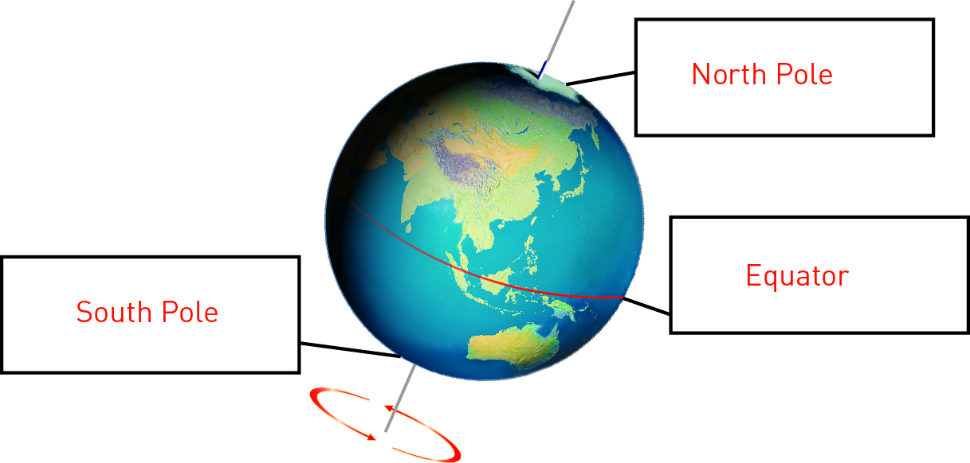

3 At the equator, the world rotates at 1670 kilometres per hour. How many kilometres would it travel in:

a one minute?

28 kilometres

b one day?

40 080 kilometres

c one non-leap year?

14 629 200 kilometres

4 The diagrams below show the position of the Sun, Earth and Moon during a solar and lunar (Moon) eclipse.

a What is the position of the Moon during a solar eclipse?

During a solar eclipse, the Moon is between the Sun and the Earth.

b What is the position of the Moon during a lunar eclipse?

During a lunar eclipse, the Earth is between the Sun and the Moon.

WORD DETECTIVE

5 Word search

Find the words listed in the puzzle below.

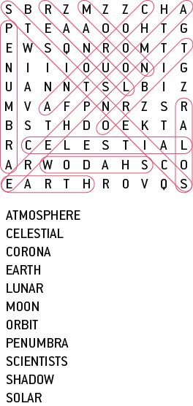

9.2 The Moon reflects the Sun’s light

Literacy support worksheet answers (pages 158–159)

Phases of the Moon

1 Below is a diagram showing the phases of the Moon.

Fill in the table to show the phase of the Moon.

|  |  |
| --- | --- |
| 1 | New Moon |
| 2 | Crescent |
| 3 | First quarter |
| 4 | Waxing gibbous |
| 5 | Full Moon |
| 6 | Waxing crescent |
| 7 | First quarter |
| 8 | Crescent |

2

a How did Galileo, the first astronomer, observe the Moon?

Galileo observed the Moon through a telescope.

b What shape is the Moon really? Explain why the Moon sometimes looks different shapes.

The Moon is really round, but it looks different depending on which parts are lit by the Sun.

3

a When did people first land on the Moon?

1969

b Who were the first two people on the Moon?

Neil Armstrong and Edwin (Buzz) Aldrin were the first two people on the Moon.

c How did the astronauts move around on the Moon?

The astronauts found that ‘kangaroo hopping’ was easier than walking on the moon because the gravity of the Moon is only one-sixth that of Earth’s gravity.

WORD DETECTIVE

4 Mumbo-jumbo

a Use the marked letters to find the secret word (e.g. olusntoi = solution).

b Unscramble each of the clue words below to find the message.

Secret word: ROTATION

R

N

Message: THE MOON RISES AND SETS ON THE HORIZON

9.3 Seasons are caused by the tilt of the Earth

Literacy support worksheet answers (pages 160–161)

Seasons

1 Below is a diagram showing the Earth’s rotation around the Sun over a year. Fill in the boxes to explain what happens to deciduous trees (those that loose their leaves) when the Earth is in a different position, for each season in Australia.

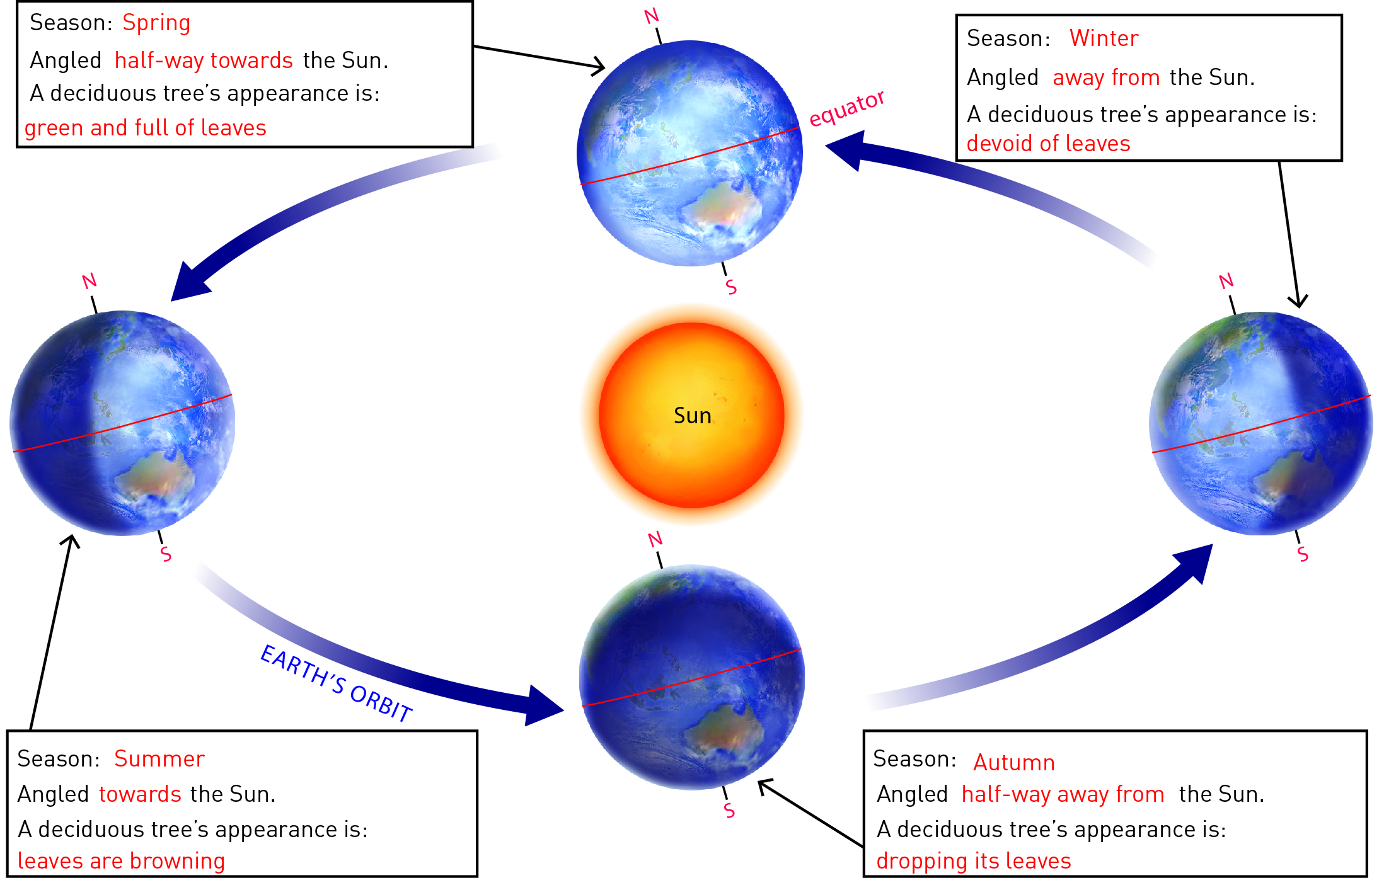

2 What does the tilt of the Earth do?

The tilt of the Earth on its axis causes the northern and southern hemispheres of the Earth to point towards or away from the Sun as the Earth orbits the Sun, giving us our seasons.

3 Fill in the boxes in the diagram below to explain what is happening in the Northern Hemisphere in the United States of America when the Earth is in the different positions.

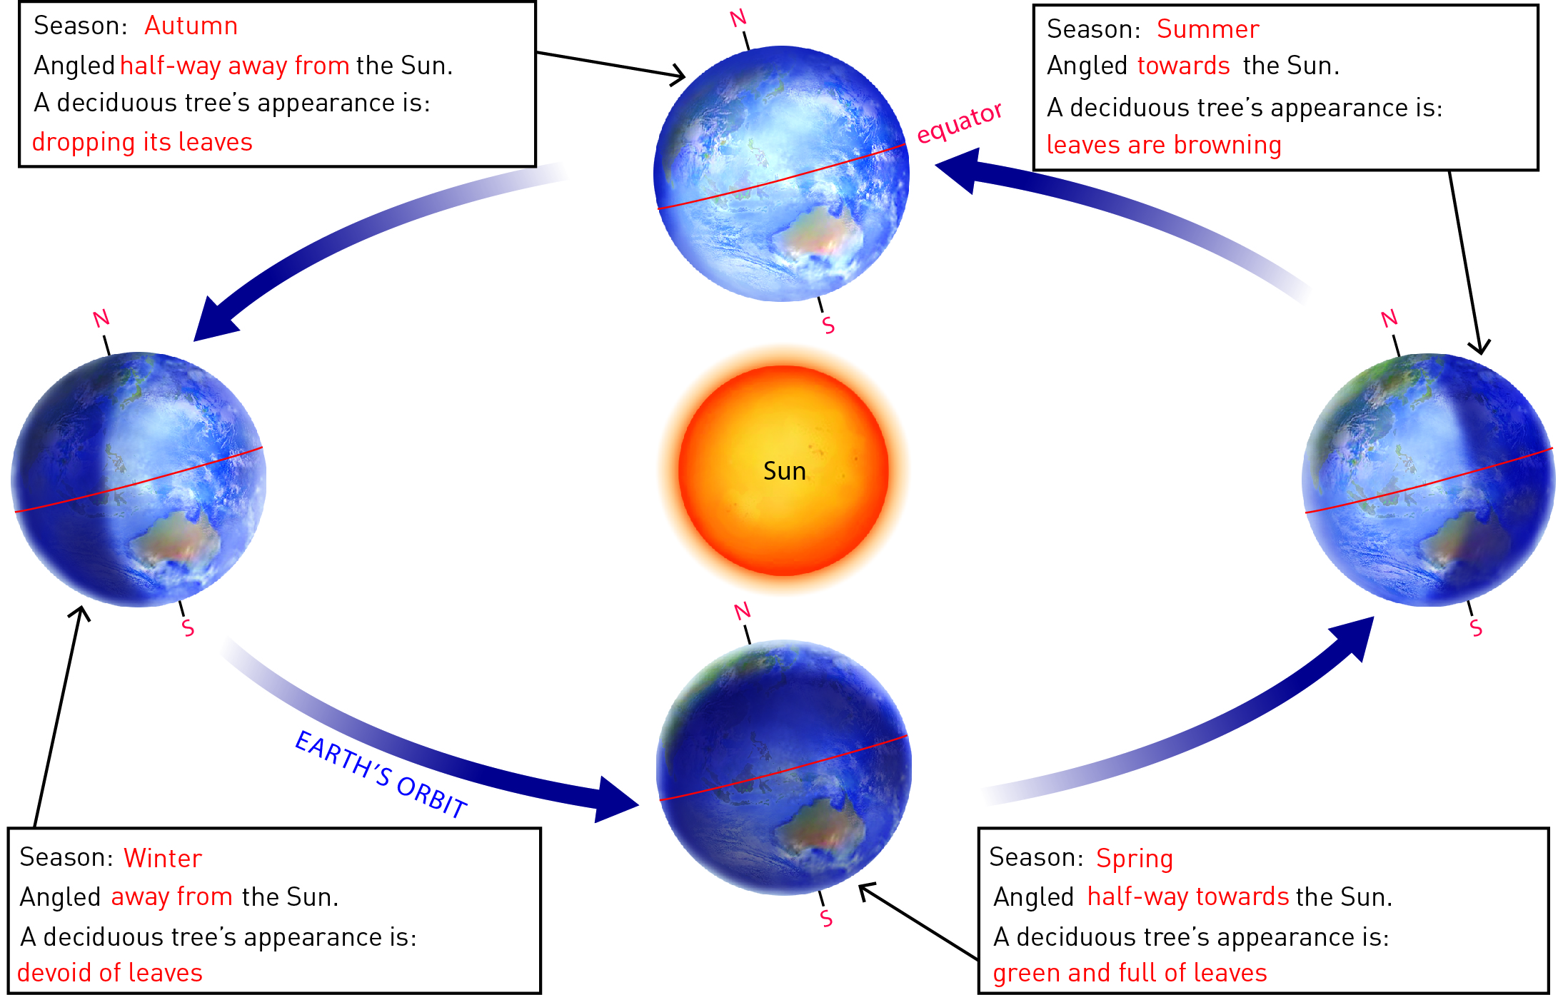

WORD DETECTIVE

4 Word search

Find as many words as possible in the puzzle below.

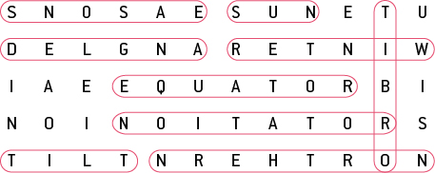

9.4 Science as a human endeavour: Astronomers explore space

Literacy support worksheet answers (pages 162–163)

Astronomy

1 Describe the ways that ancient astronomers used their observations of the stars, Sun and Moon to help them.

a The movement of the planets helped them to:

calculate time, as well as the best times to plant crops, and to develop calendars and determine the seasons.

b The positions of the stars helped them to:

navigate the oceans.

2 What information can be gathered by using telescopes?

Telescopes can be used to gather information about distant galaxies and stars that would otherwise be impossible to get.

3 The image here is of an astronaut exploring the surface of Mars. In the background you can see a moon of Mars and also the planet Earth.

a Is the image real or fake?

Fake

b What are some factors that helped you reach your conclusion?

Student responses will vary but could include that humans have never travelled to Mars and the fact that the Earth would be a small dot of light when viewed from Mars.

WORD DETECTIVE

4 Crossword

Read the clues below and place the correct answers in the crossword boxes.

